2nd Assessment Report
Hao Gu
Student id: 50098805
- Introduction
The Smart Home Automation System is designed to revolutionize the way we interact with and manage smart devices within a home environment. The program encapsulates the attributes of different classes and basic methods such as setter and getter to achieve mutual calling between objects. Finally, the program provided different interfaces for users to manage it.
This project focuses on several key educational goals. Firstly, this program incorporates some basic concepts from Python’s OOP in its design, including encapsulation, abstraction, inheritance and polymorphism. Secondly, in the process of program design, different design patterns are included, including Singleton. Thirdly, in the implementation process of the program, it is required to master different types of data structures. Devices is the parent class of each device, providing basic methods and attributes. DeviceController is the control center responsible for managing and scheduling various device subclasses. SmartHomeHub contains abstract functions to meet real-world requirements.
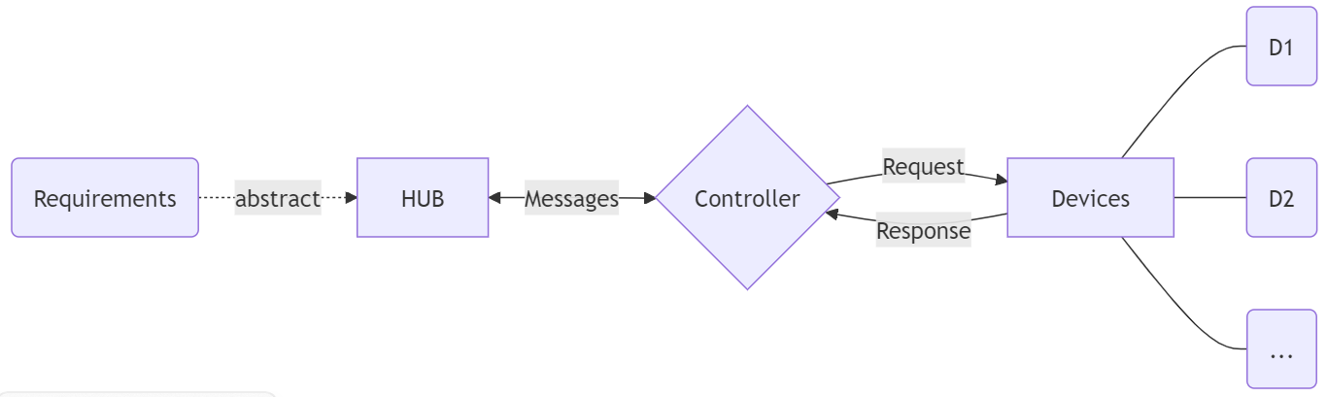
- Device Class Design
As the parent class of smart furniture, Devices provides initialization function and many basic attributes for different devices, which are its subclasses. The basic attributes include: device_id, name, energy_usage, status. These attributes are defined as private variables (Add two ‘__’ before the variable name) to achieve encapsulation effects. Getters and setters provide different interfaces, which not only hide private attributes but also provide methods for calling and modifying private variables.
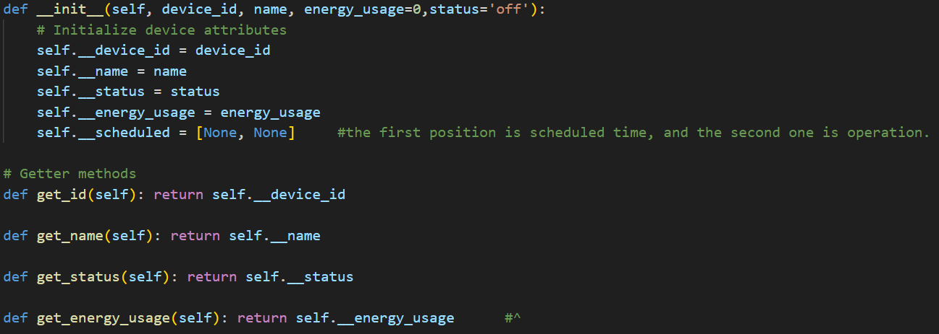
Turn_on () and Turn_off () are essentially functions with the same method but opposite operations. In order to improve the reusability of the code, I have added an additional function set_status (new_status).
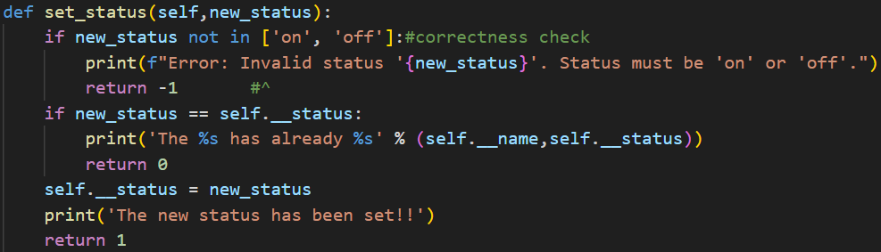
Added correctness check on input parameters in the function set_status (), increasing code security. At the same time, return values (-1,0 or 1) have been added to the set_status() function. By calling the function, the return value can be used to determine whether the operation has been successful or if an error has occurred.
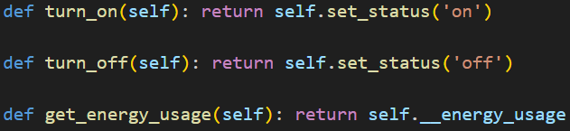
Finally, the functions turn_on(), turn_off() and get_energy_usage() only require simple method and property calls.
Three subclasses have been added to the program, including Light
, Thermostat, Camera. Meanwhile, the function add_device () is automatically called during initialization to add the new device to the dictionary of devices, in order to improve code efficiency.
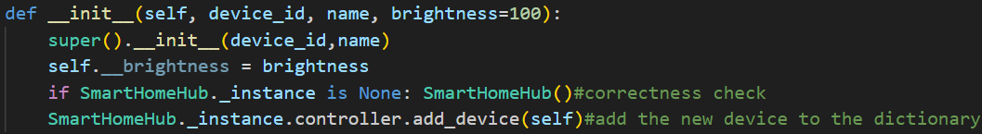
Although the initialization logic of subclasses is different, they share the Devices interfaces (such as get_status()), allowing DeviceController to manage all devices uniformly. This reflects polymorphism. If necessary in the future, new functions can be added to subclasses to achieve the overwriting.
- Device Controller Class Design
The program uses dictionaries (devices) to map device IDs to device objects. Meanwhile, add '*devices' to enable batch joining of devices.
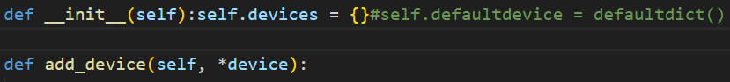
A dictionary has the following advantages:
- O (1) Time complexity addition, deletion, and search operations.
- Ensure the device ID is unique, ensuring data security.
- Efficient memory storage and mapping based on hash table.
After studying and carefully considering defaultdict ^{[1]}, I want to suggest that defaultdict haven’t been adopted. Because defaultdict automatically creates key value pairs, incorrect operations may contaminate the dictionary. Therefore, I still use traditional dictionaries and manually maintain them.
Device controller class has four main methods.
- Add device:
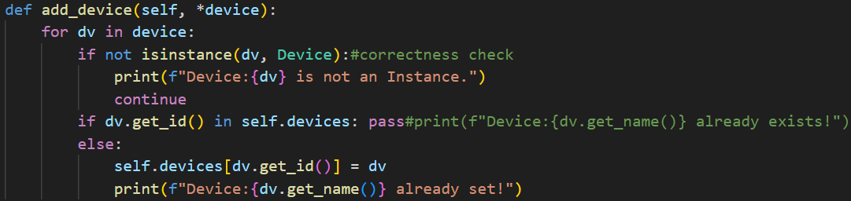
Traverse each new device through a for loop. Since each class object is already added to the dictionary during initialization, if conditional statements skip the addition operation, aiming to improve code execution efficiency. This check ensures that each device ID remains unique, maintaining the integrity of the system.
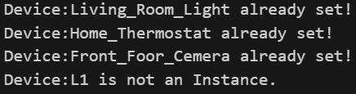
- List device:
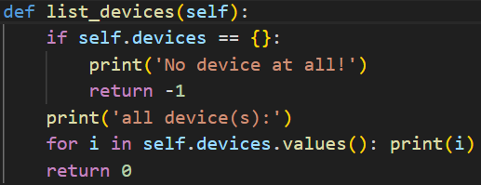
Call the built-in Python function '__str__' to output the devices and its attributes. Use '\t' to make the output content more aesthetically pleasing.
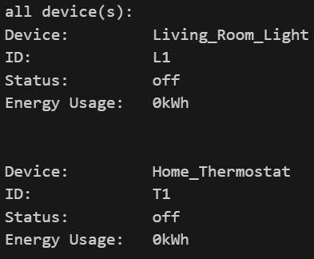
- Execute command:
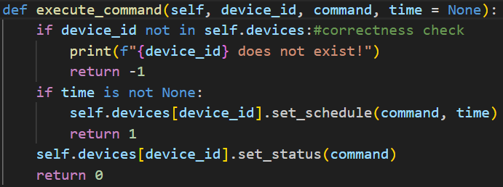
A default argument, 'time', is provided in this function, which provides reusable code for the function schedule_task().In this function, correctness checking of arguments is also required, checking and returning non-existent device IDs. Finally, by using the default parameter 'time', call function set_schedule() and function set_status() separately to achieve different effects and achieve function overloading.
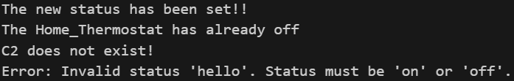
- Remove device:
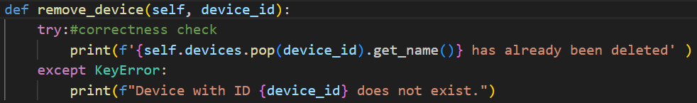
The remove_device() method allows for the removal of devices from the system by their IDs. To simplify the code, the 'try-except' method is used here instead of traditional correctness checking. Provide a unified error message for possible errors, such as incorrect ID, non-existent ID, inability to delete, etc. Exclude potential hazards in the code and comply with OOD safety and concise design requirements.
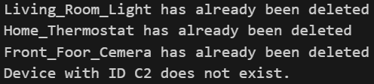
- Smart Home Hub Class Design
SmartHomeHub and DeviceController are both unique, so a singleton needs to be created for them. This can avoid creating multiple instances, which can interfere with each other and affect code efficiency.
The Singleton pattern is implemented by overriding the __new__() method. When calling the constructor, if _instance is NONE, create an instance SmartHomeHub and assign it to _instance, while initializing DeviceController. Otherwise, return the value of _instance.
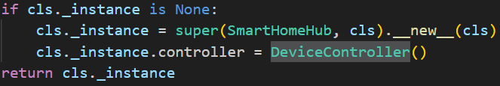
Device controller class has three main methods.
- Schedule task^{[2][3]}:
In this method, code reuse is achieved directly by using the default parameters in the method execute_command(). At the same time, the default parameter 'time=None' is retained in this method, which modifies the current device state.
- Display status:
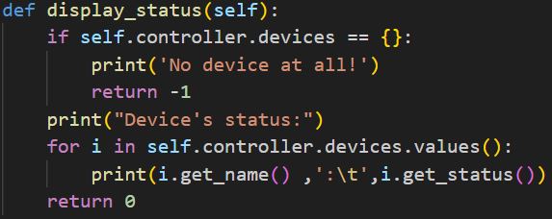
In this method, a for loop is used to call instances in the dictionary one by one and print their names and statuses. Simultaneously using '\t' to make the output more aesthetically pleasing. It cannot be ignored that if the dictionary is empty, meaning there are no devices, additional output results need to be made.
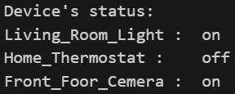
- Total energy usage:
In this method, the built-in iterators^{[4]} in Python are fully utilized to iterate through the values in each dictionary, that is, each device, and recursively accumulate them to obtain the total energy consumption.
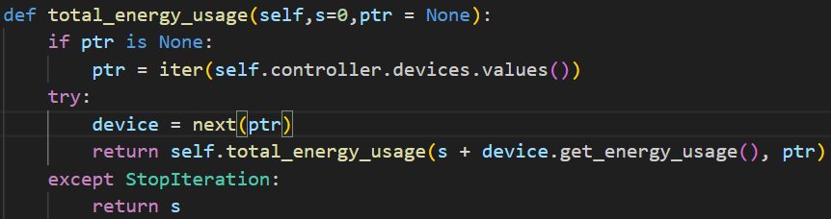
In recursion, we need to maintain the total energy 's' and the iterator pointer. Call the method get_energy_usage() to accumulate the sum 's' and point the iterator pointer to the next value. Thus achieving the use of iterators and recursion to calculate the total energy consumption.
SmartHomeHub calls methods in the Controller through self.controller and further passes arguments to them. In fact, the SmartHomeHub class is tightly integrated with the DeviceController class to form a cohesive and functional system. In DeviceController, a dictionary that can be mapped to devices and basic methods for managing devices are stored. In SmartHomeHub, various abstract methods are encapsulated to meet different real-world needs. This includes reservation functions, calculating total energy consumption, and so on.This shows that the abstract methods in SmartHomeHub need to repeatedly call the DeviceController interfaces to achieve interaction between various subclasses, that is, devices.
- Testing and Demonstration
The testing approach for the Smart Home Automation System involves using the Python unittest^{[5]} framework to ensure the reliability and correctness of the implementation. Common testing methods include using assert statements to compare whether the correct answer is given.
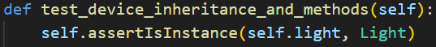
Obviously, the test samples built by the unittest framework in the test.py file are not sufficient to test the entire system. Therefore, I have written some additional test samples for edge testing.
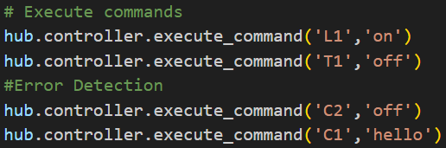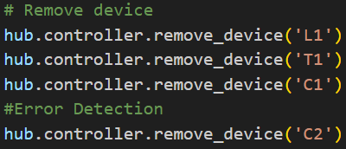
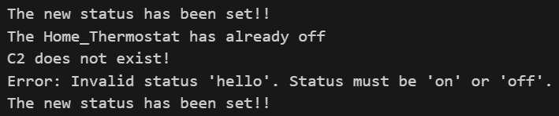
Above all, automated tests play a crucial role in maintaining the quality of the system.
Due to the fact that the class Devices does not provide an interface to outside, it is difficult for us to explicitly test the methods within it. However, the execute_command() and schedule_task() in Controller can implicitly test whether there are errors in the methods in Devices. 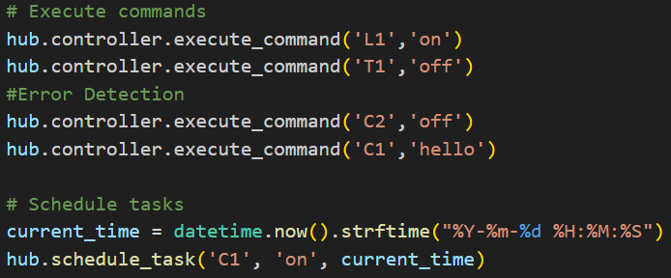
For the classe DeviceController and SmartHomeHub, we have already provided a detailed introduction to the core code and results in the previous section. We will not get into the specifics here, but only provide some test samples to the basic testing methods.
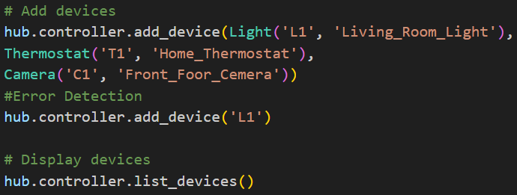
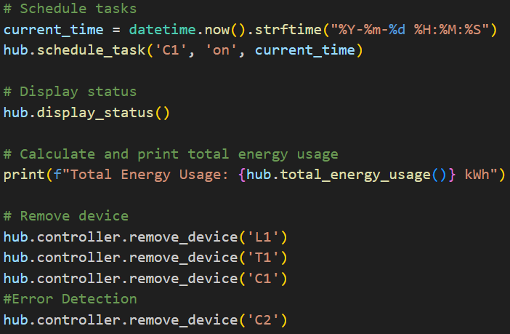
But these tests are not enough. I conducted additional testing on whether the SmartHomeHub class is a singleton. The results show that both addresses are the same, so it is a singleton.
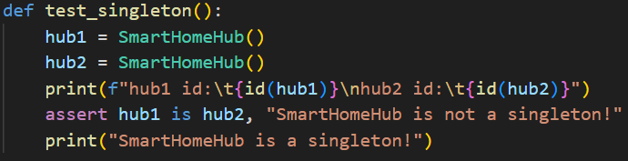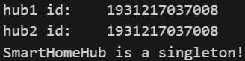
The test results show that all implemented tests pass, indicating that the system functions correctly and reliably.
- Conclusion
In this project, the smart home control system was completed beyond expectations. At the same time, the system has good work efficiency and operational capabilities. By implementing the system using Python's OOP features such as inheritance, polymorphism, encapsulation, and abstraction, we achieved the goals of adding/removing devices, commanding devices, monitoring system states, managing energy consumption, and scheduling tasks.
During the development process, the project presented numerous challenges, such as correctly implementing singleton patterns and ensuring proper interaction between objects. The experience gained from this project highlights the importance of OOP principles in creating scalable, maintainable, and efficient software systems.
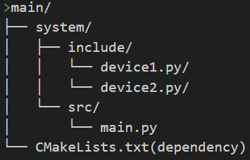
In the future, there is still room for improvement in this project. We can separate the source code containing subclasses of devices from the main function and call the subclass source code through dependencies. This project structure is clearer and helps to further expand the functionality of subclass devices.
- References
[1] https://docs.python.org/3/library/collections.html#collections.defaultdict
[2] https://docs.python.org/3/library/datetime.html
[3] https://schedule.readthedocs.io/en/stable/
[4] https://docs.python.org/3/library/stdtypes.html#iterator-types
[5] https://docs.python.org/zh-cn/3/library/unittest.html

def countDescendants(node):
if node is None:
return 0
count = 0
for child in node.children:
count += 1 + countDescendants(child)
return count

